

**Software Major Project:**

**Check 4**



By: Tongyu Hu (436016921)

Teacher: Mr Shirlaw

Class: Software Design Year 12

Due date: Week 1 Term 3

Test Report

**Item being tested:** Singleplayer controls module

**Date:** 07/07/2021

**Tester:** Tongyu Hu

**Type of test:** Black box test

**Appendix 1:** Test data and the expected results

**Appendix 2:** Table of actual results

**Interpretation of test**

* The player controls module within singleplayer was tested to ensure that player movement was smooth and intuitive though issues arose within certain controls and the movement of the camera which can be fixed
* Typical and non-typical inputs were all tested, as the module was subjected to thorough testing to ensure no runtime or logic errors are present
* Also tested all pathways and boundary conditions to ensure that no errors would arise during the final release of the game itself
* The game controls functioned relatively well, allowing for the player to control the movement of the character and the camera. The camera relative movement also performed surprisingly well though had a few minor issues which can be rectified.

The issues that were identified are discussed below:

1. The control of the 360-player camera for its upward and downward motion seemed to be inverted to what was expected (downwards mouse movement was not equal to downwards pan of camera)

* This can be fixed with editing the code for the 360 camera, which can be done just by inverting the controls again so that the camera moves in the direction of the mouse

1. To control the player, only the W, A, S, D keys functioned, but not the keyboard arrows, which was unexpected

* This can be attributed to the newly designed camera relative movement in which the movement of the player is not relative to the world map but the direction in which the camera is moving. This means that the keyboard arrows may have not been programmed into the game itself though is not a high issue as players predominantly use W, A, S and D keys to control the game.

1. The press of the escape button paused the game, though the navigation menu to resume, check controls or quit the game did not show, preventing the user from controlling the game further

* This is a more pressing issue that needs to be rectified though should be a moderate task to complete by editing the game panel itself and the code that is connected to it

1. There was shuddering in the movement of the player when going forwards and backwards

* This error must be fixed as it decreases the immersion of the player when controlling the character though may have something to do with the rotation of the character which is a sphere

**Appendix 1: Test data and the expected output**

|  |  |
| --- | --- |
| **Input** | **Expected Output** |
| Keyboard press of ‘W’ | Player moves forward in the direction that the camera is pointed at |
| Keyboard press of ‘S’ | Player moves backward in the direction the camera is pointed at |
| Keyboard press of ‘A’ | Player moves left in the direction the camera is pointed at |
| Keyboard press of ‘D’ | Player moves right in the direction the camera is pointed at |
| Keyboard press of ‘up arrow’ | Player moves forward in the direction the camera is pointed at |
| Keyboard press of ‘down arrow’ | Player moves backward in the direction the camera is pointed at |
| Keyboard press of ‘left arrow’ | Player moves left in the direction the camera is pointed at |
| Keyboard press of ‘right arrow’ | Player moves right in the direction the camera is pointed at |
| Keyboard press of ‘up’ | Player jumps |
| Keyboard press of ‘esc’ | Paused game and shows the menu of options available to player |
| Keyboard press of ‘B’ | Nothing happens |
| Keyboard press of  ‘$’ | Nothing happens |
| Mouse moves to right | Pans player camera to the right |
| Mouse moves to left | Pans player camera to the left |
| Mouse moves up | Pans player camera up |
| Mouse moves down | Pans player camera down |

**Appendix 2: Table of actual results**

|  |  |  |
| --- | --- | --- |
| **Input** | **Actual Output** | **Accurate?** |
| Keyboard press of ‘W’ | Moves forward in direction the camera is facing though a bit jittery | Yes/No |
| Keyboard press of ‘S’ | Moves backward in direction the camera is facing though a bit jittery | Yes/No |
| Keyboard press of ‘A’ | Moves left in direction the camera is facing | Yes |
| Keyboard press of ‘D’ | Moves right in direction the camera is facing | Yes |
| Keyboard press of ‘up arrow’ | Nothing occurs | No |
| Keyboard press of ‘down arrow’ | Nothing occurs | No |
| Keyboard press of ‘left arrow’ | Nothing occurs | No |
| Keyboard press of ‘right arrow’ | Nothing occurs | No |
| Keyboard press of ‘up’ | Player jumped | Yes |
| Keyboard press of ‘esc’ | Paused game though menu of options did not come up | No |
| Keyboard press of ‘B’ | Nothing happened on screen | Yes |
| Keyboard press of  ‘$’ | Nothing happened on screen | Yes |
| Mouse moves to right | Pans player camera to the right | Yes |
| Mouse moves to left | Pans player camera to the left | Yes |
| Mouse moves up | Pans player camera down | No |
| Mouse moves down | Pans player camera up | No |

Comparison with Original Specification

In comparison to the original specifications, the overall game has deviated moderately in its final design and the processes that were undertaken deviated slightly, thereby changing some of the initial user and developer requirements. Although this has occurred, the final product is arguably more refined, as extra steps that were not initially considered were incorporated into the project such as the development of new features in terms of character control and the user interface.

**Design specifications:**

The requirements that were not truly met (yellow) and newer ones that were incorporated (green) are highlighted below:

**Tailored for user perspective:**

|  |  |  |
| --- | --- | --- |
| **Category** | **Number** | **Requirement** |
| Application interface | 1 | Ergonomic, Intuitive, and well thought out user interface  (Sticking to design standards the whole way) |
|  | 2 | Visual and audio outputs to engage user |
|  | 3 | Legible and appropriate text/icons to direct user |
|  | 4 | Consistent and judicious use of cool colours and form |
|  | 5 | Keyboard shortcuts for easier and efficient navigation |
|  | 6 | Scene transitions to provide a smoother experience |
| Application support | 7 | Help and tutorial section to provide assistance |
|  | 8 | Labelling of buttons and controls for controlling the player |
|  | 9 | Settings menu for adjusting visual and gameplay requirements |
| Application usability | 10 | Movement and control of character to be standardised for each player |
|  | 11 | Multiplayer system to have minimal lag between interactions for players |
|  | 12 | Consideration for social and ethical issues such as disability, gender, and inclusivity |
| Application fluidity | 13 | Satisfactory frame rates during gameplay (above 30fps and optimised for a wide range of devices) |
|  | 14 | Quick response times for connecting to server and running game on devices |

1. **Requirement not met: Number 5 in Application Interface**

* This requirement involved adding keyboard shortcuts to effectively provide more efficient navigation to consider individuals with physical disabilities or to improve the UI in general
* As the game was developed in mind to provide smooth and effective gameplay, the keyboard shortcuts were of lower priority within the design of the system itself. Due to this, not many were developed
* Although this is the case, the application still can interface correctly with the Mac OS system so generalised keyboard shortcuts built into the OS itself such as (command + Q) can quit the app effectively

1. **Requirement added: Number 6 in Application Interface**

* Upon the development of the game, an extra requirement to provide scene transitions was added to enrich the user experience with the game itself
* As such, this has allowed for the navigation of the game to become smoother and provides more information to the user through a progress bar to indicate that the next game scene is loading

1. **Requirement not met: Number 12 in Application Usability**

* As a result of limited time constraints, like the keyboard shortcuts, the overall system does not have a high degree of support for social and ethical issues such as gender or disability
* It does, however, have a help menu and a few keyboard shortcuts that improve the usability of the program itself
* Further support can be added in the future so that the game appeals to a wider range of users

**Tailored for developer perspective:**

|  |  |  |
| --- | --- | --- |
| **Category** | **Number** | **Requirement** |
| Application development | 1 | Structured development approach |
|  | 2 | Check back on objectives after each week to ensure quality of software |
|  | 3 | Adherence to Unity trademark guidelines |
|  | 4 | Use of data dictionaries, IPO chart, Data-flow diagram, EBNF/Railroad diagrams and other forms of system modelling tools |
| Application code | 5 | Well use of internal and intrinsic documentation with effective white space for increased readability |
|  | 6 | Standardised C sharp coding language with use of Unity Engine |
|  | 7 | Free from malware or other forms of internal system bugs |
|  | 8 | Appropriate data types and use of standard control structures |
|  | 9 | Clear and uncluttered mainline and reusable code for efficiency of program |
| Application review | 10 | Use of surveys and even interviews for feedback and review of system |
|  | 11 | Internal and external testing |
| Application use  (Internal and background) | 12 | Compatibility with Mac and Windows operating systems without affecting other applications |
|  | 13 | Compatibility with IOS devices |
|  | 14 | Free from logic, syntax, and runtime errors |

1. **Requirement not met: Number 10 in Application Review**

* Due to time constraints, surveys were not incorporated within the reviewing process of the game along with formal interviews
* The display of the game to friends and family was utilised to replace this, allowing for informative feedback that allowed for subsequent redesigns of the game though was not as effective as it could have been
* Although this has occurred, the overall product is relatively refined and should be functioning without errors

1. **Requirement added: Number 13 in Application Use**

* Upon further investigation with the Unity build settings, there are extra modules that can be installed to provide support for differing platforms and in this case IOS
* Due to this, with the help of XCode, I was able to create a working version of zenith to run on both iPhone and iPad, and effectively works with a keyboard connected

**Comparison with original screen designs**

The final design of the UI and menu differed in that the game itself has a much less cluttered interface, that provides a smoother experience to the user overall when compared to the original screen design. Additionally, the initial game view was very similar to what was drawn up within the initial screen design, though lacks the helpful tips that appeared in the bottom section of the screen. Nevertheless, the final design of the UI is effective and intuitive, allowing for a streamlined experience.

The screen design and actual game UI are shown below:

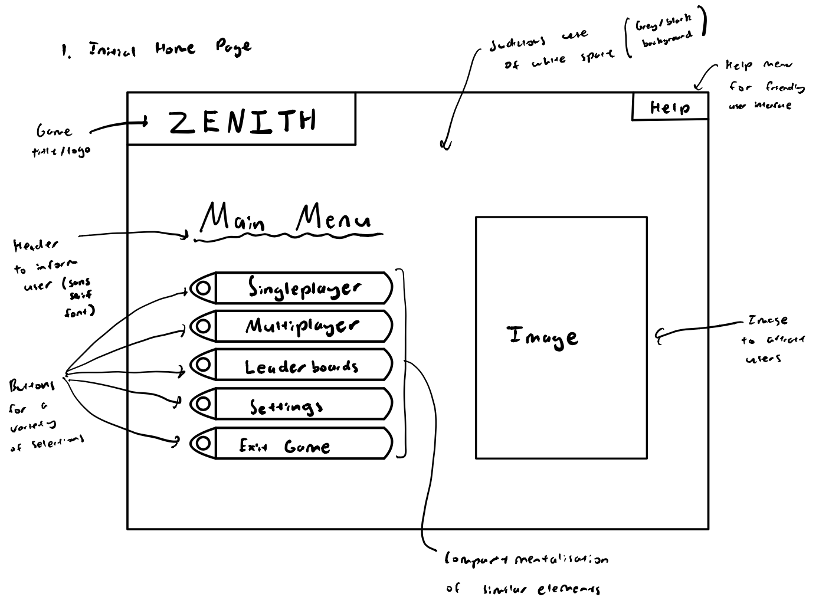

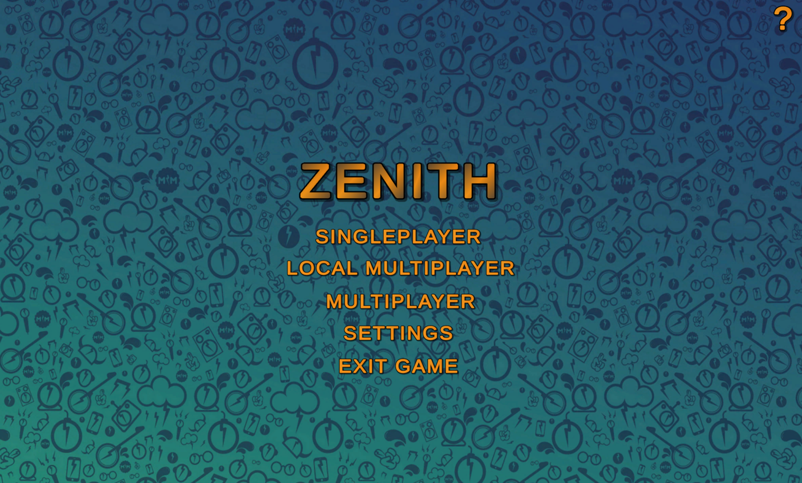

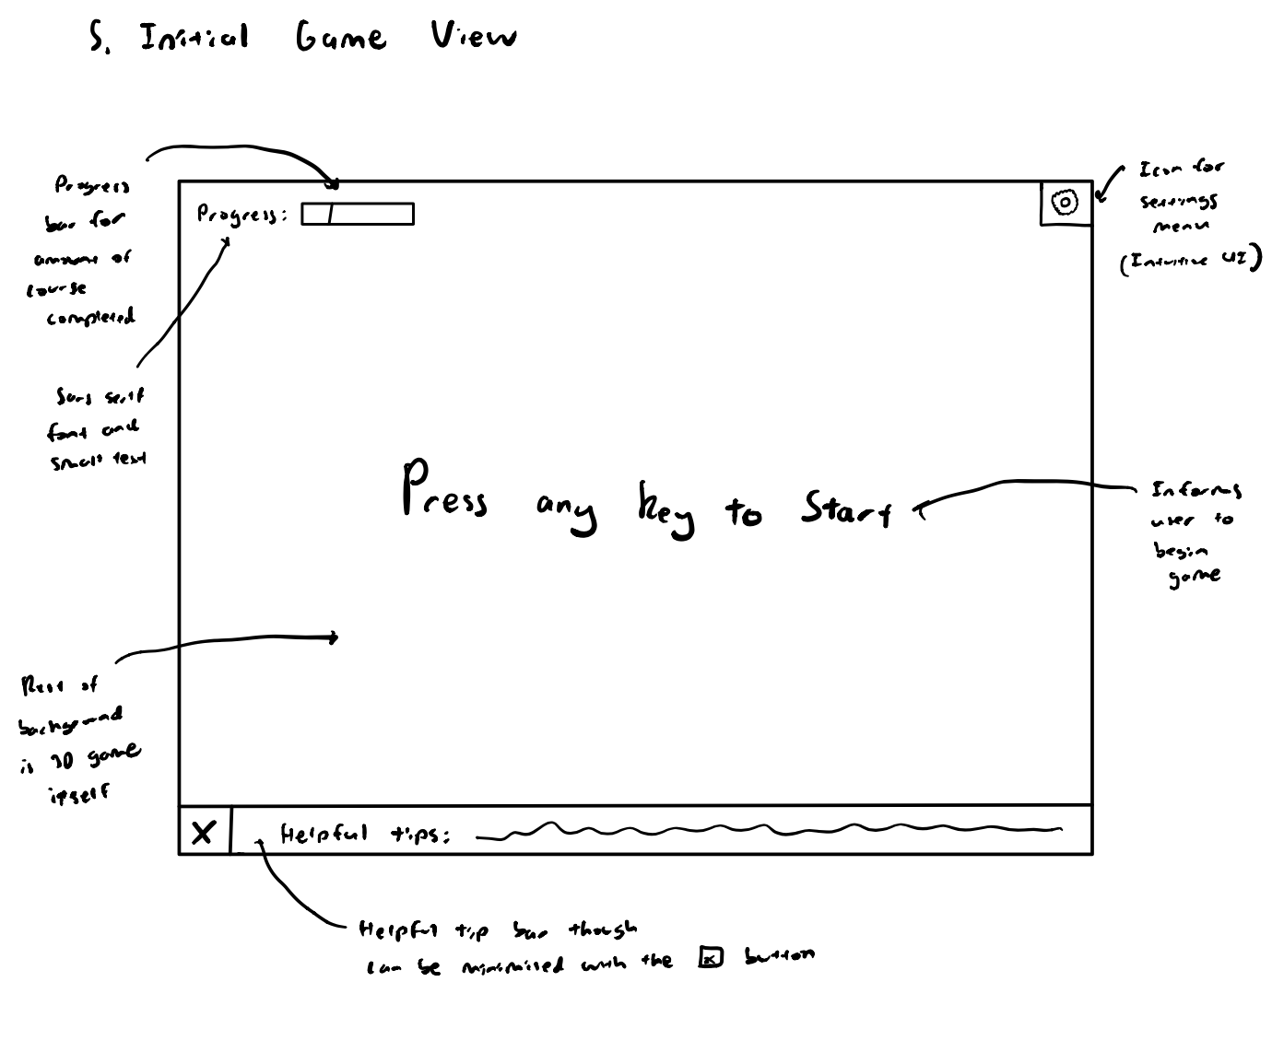

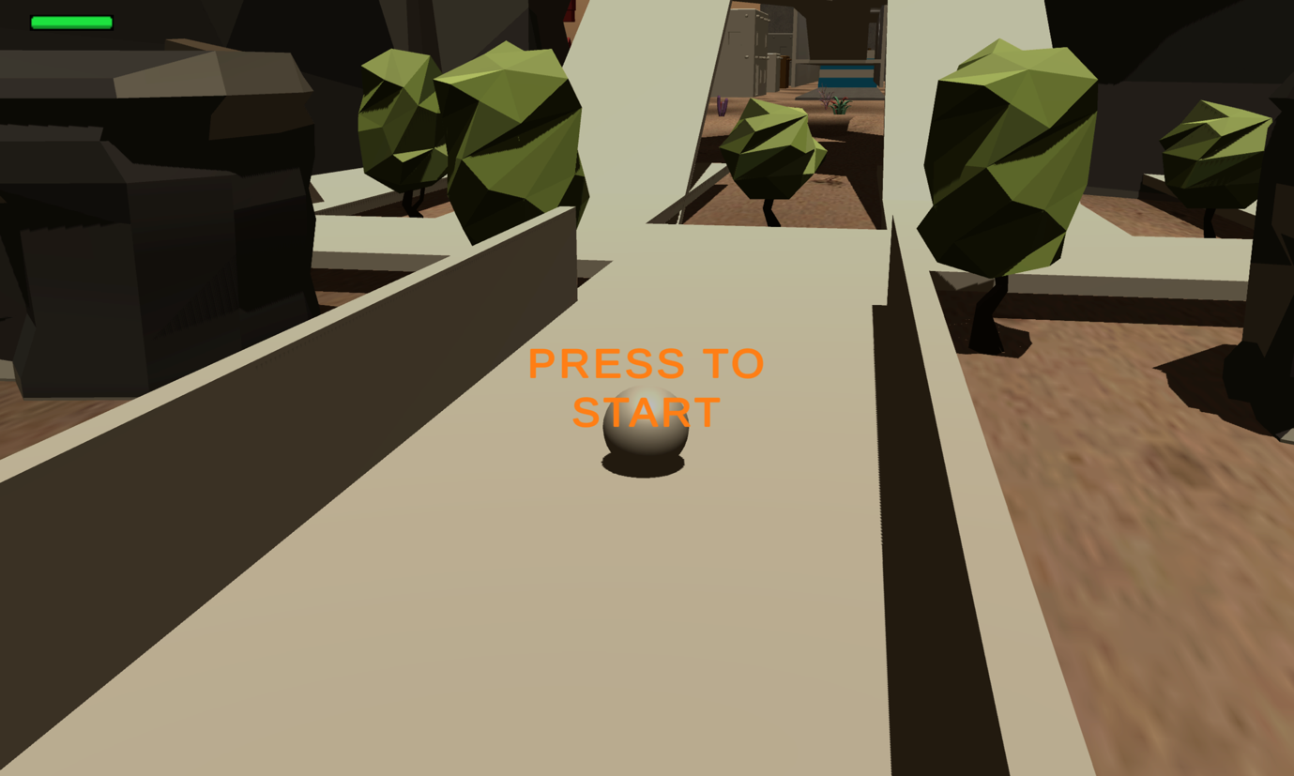

Efficiency and Elegancy of Code

1. **Meaningful identifiers**

Meaningful identifiers promote the readability of the code to the developer and other developers who may update the program. Thus, this improves the projects maintainability in the future while enhancing the quality of the code so that it may be able to be reused in the future. Seen in the example below, the use of meaningful identifiers of groundedPlayer and playerName significantly improves the way that the code can be understood.

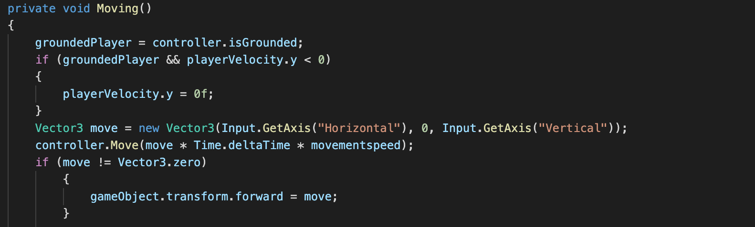

1. **White space**

Using white space, it allows for sections of the code to be identified and segregated to promote modularity while also enhancing the way the code can be better understood. Due to this, it allows for the elegant design of code as it improves its quality due to readability. Seen below, the white space separates the different functions that are within the main class that gets player input for their username.

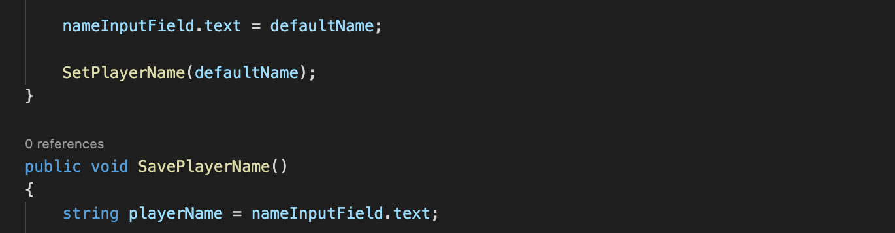

1. **Indentation**

Indenting code will allow for visual confirmation of the scope of certain variables within a program and how each section of code fits into certain subroutines or modules that make up the entire program. This allows for elegant code to be produced so that future updates are easily made. The code below depicts how indentation allows for the IF and WHILE loop to be easily seen in the hierarchy within the module LoadAsynchronously()

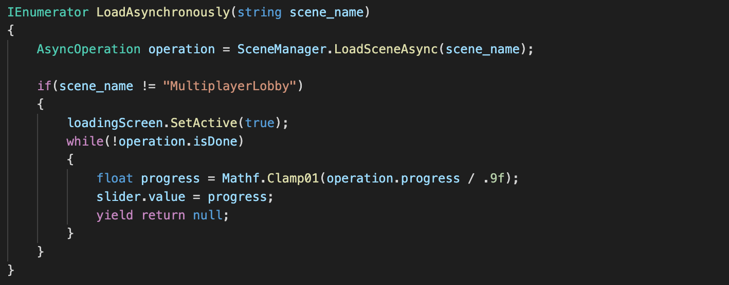

1. **Code comments**

Code comments allow for a brief description of what the code does to allow for the code to be better understood. In addition, they are also used to explain the function of a section of code in cases where the purpose of specific subroutines may be unclear to other developers. The example below depicts the use of good code comments to depict the function of the resolutions loop.

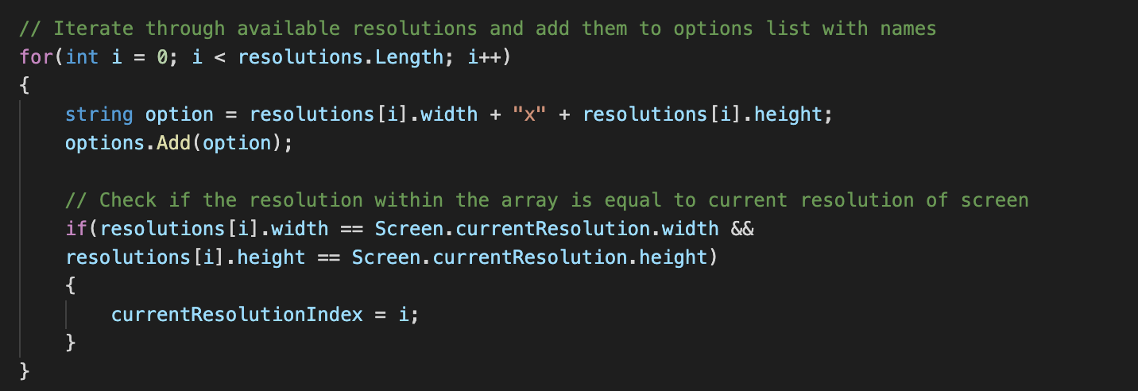

1. **Variables to hold values instead of literal constants**

By using variables to hold values instead of literal constants, this allows for the code to be easily altered during maintenance if there is a requirement to change certain values within the code. This ensures that all references to it will change in value to promote efficiency during the development or maintenance process. The above picture depicts how the movementspeed, jumpHeight and gravityValue are all variables to hold constants.

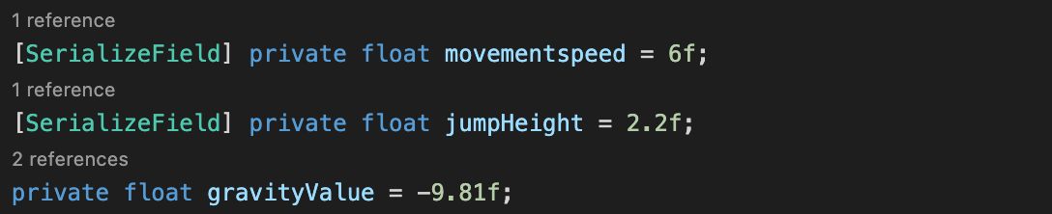

**Extra note:**

For further analysis of the elegancy of the code that I have created, within the screenshot of “Indentation” the section of code is a module named LoadAsynchronously (). This module allows for the new game scene that is about run such as when a player clicks the singleplayer button to first load within the background, while a loading screen named ‘loading Screen’ appears, to display the progress of loading due to the game scene being large. This promotes efficiency within the game itself, as it does not appear to freeze which is the case for inefficient code to load the scene in the past.

Alpha and Beta testing

1. **Alpha testing**

Alpha testing is the fourth stage of the software design process and is completed during the testing and evaluation of a software solution. It is usually completed by personnel within the software development process (i.e., the developers in most cases) and utilises real data to test the system under simulated real-world conditions. It is a form of acceptance testing so that the software can be analysed to be functioning correctly and allows the developers to check the overall quality of the solution in the perspectives of the users who will interface with the UI of the software. In doing so, it provides information to the developers about the issues that may still be present within the system before its final release so that they can be modified and fixed.

Alpha testing within the development of Zenith can be undertaken to ensure that all the controls and UI elements of the game are able to be interacted with correctly before release into a real-world environment. This would be done with two or three other developers of the project who would have the alpha version of Zenith installed on their devices, were they would be informed on the errors that should be looked out for and each tester designated a specific module of the program to test which they would subsequently interchange between so there is a higher chance to catch out any errors. Due to the multiplayer nature of the program, the developers could also analyse how well the server responds to a simulated high load, to ensure that with multiple players on the network, there would be no issues. Once issues may be found, they should be recorded by each developer and once everyone reconvenes, these errors can be discussed and subsequently fixed.

1. **Beta testing**

Beta testing also exists within the fourth stage of the software development process and like alpha testing, exists during the testing and evaluation of a software solution. It is the testing of the final solution by a limited number of users who are outside of the software development process and can provide real world data and conditions to the program so that it can be analysed under loads. This is usually done during the final stages of the software development process and after alpha testing before it is released, so that developers can ensure that there is little issue when the program is released to an even larger audience. It also acts as a form of acceptance testing so that it can meet high quality standards and allows the users to provide feedback upon the

Issues that they may have encountered during their beta test. These issues can then be addressed depending on their prevalence and will allow for the final solution to be better refined and decrease the risk of failure, so that the final release is free of issues.

Beta testing within the development of Zenith would be undertaken during the last few stages before release of the program. It would be done by distributing the beta version of the game to around 30 – 60 individuals who may show interest within the game. Their emails would be obtained, as the beta version of the game (both Mac OS and Windows versions) would be uploaded to a google drive where it could be shared with them so that they are able to download and install the game. Once this is done, a 1-week period would be given to allow for the system to be truly tested under real world conditions. Upon completion, the users will be prompted to fill out a google form, that asks about any issues that may have occurred or any other comments of suggestions that they can make. This will allow for the user feedback to be analysed and taken aboard so that the final release of Zenith is of high quality.

Refined User Interface

1. **Main Menu**

* The initial view of what users are presented with when launching the game

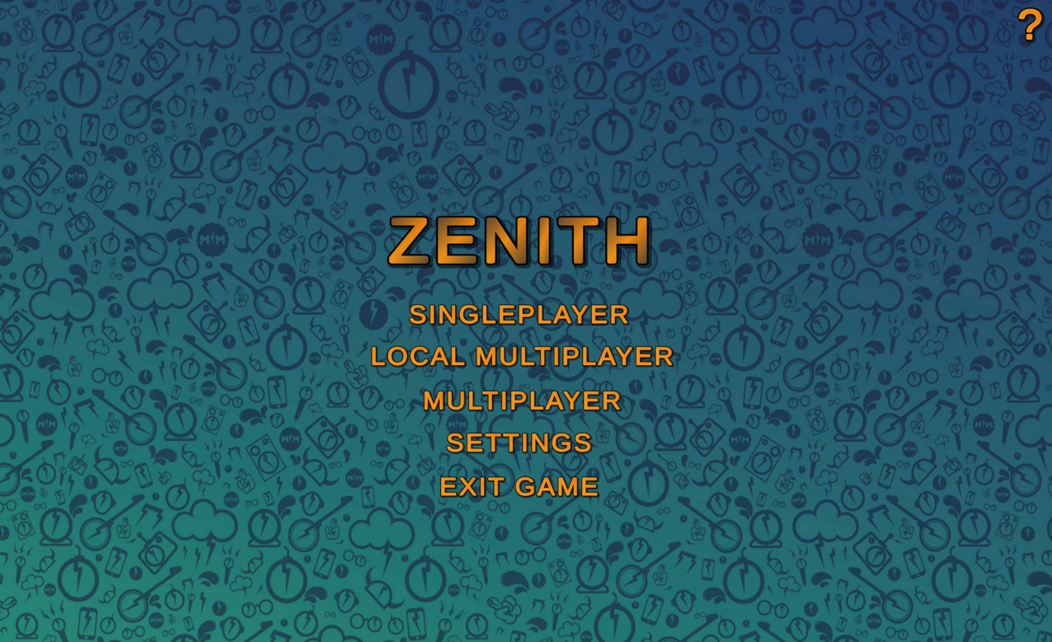

1. **Loading Screen**

* As users click on one of the options to go into either singleplayer of local multiplayer, the loading screen will display below to signify the progress of the next scene that is loading through a progress bar

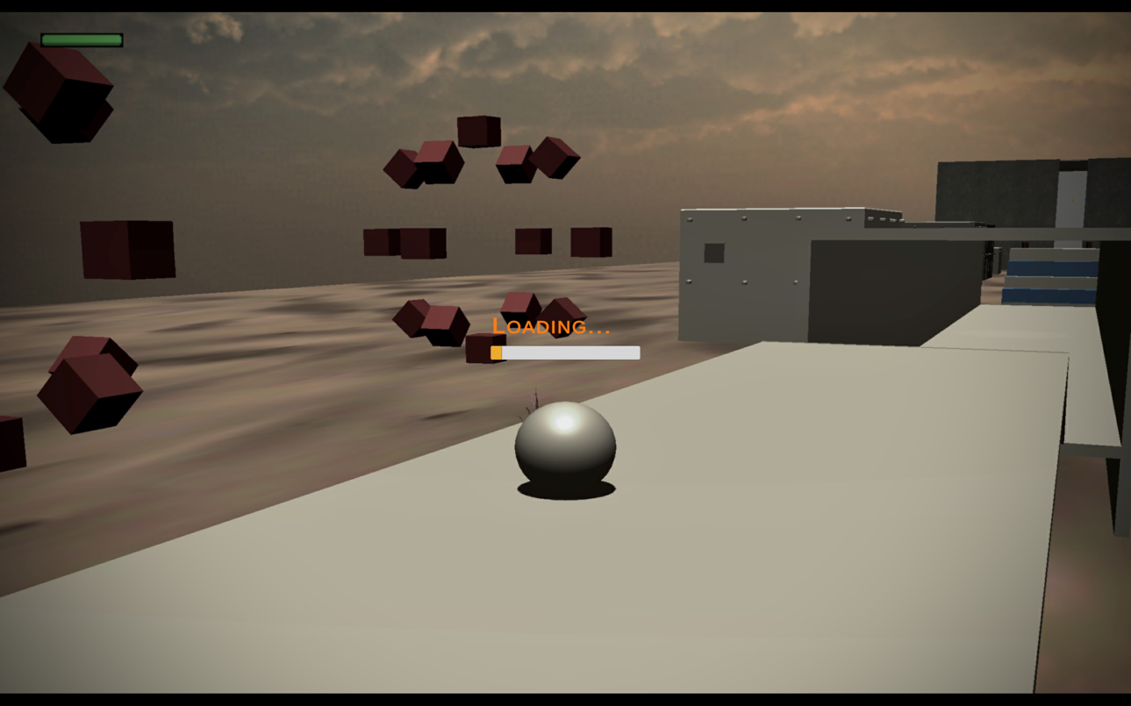

1. **Help Menu**

* Gives a brief description of the game itself and allows for users to gather more information about the program as a whole

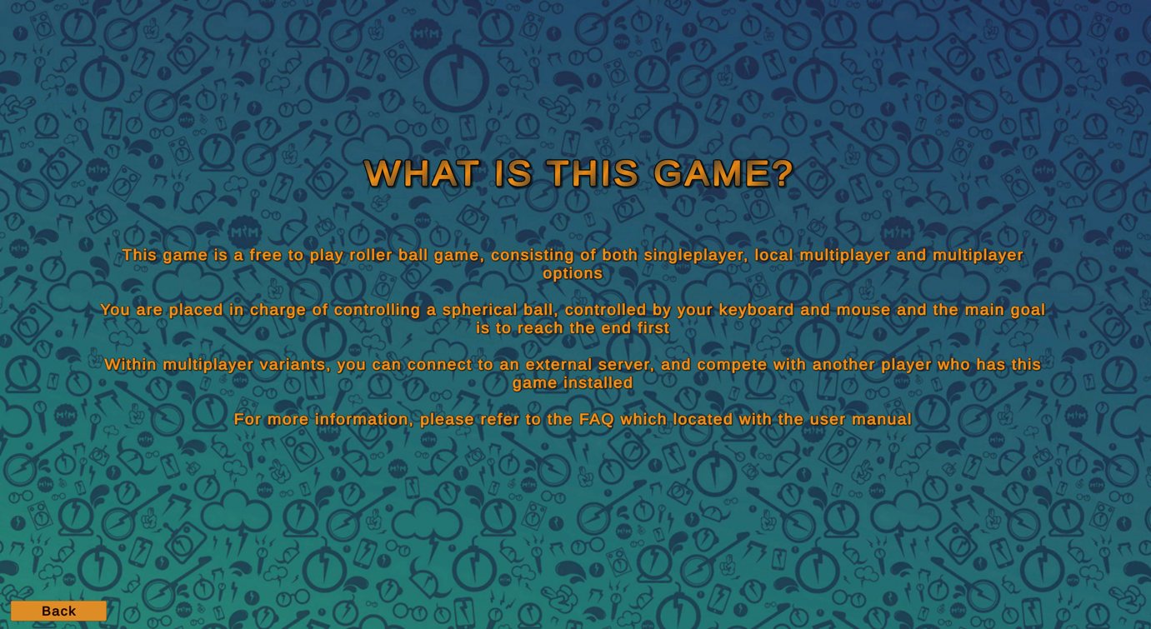

1. **Settings Menu**

* This menu allows for the control of the volume, graphics, resolution and fullscreen or windowed mode of the application

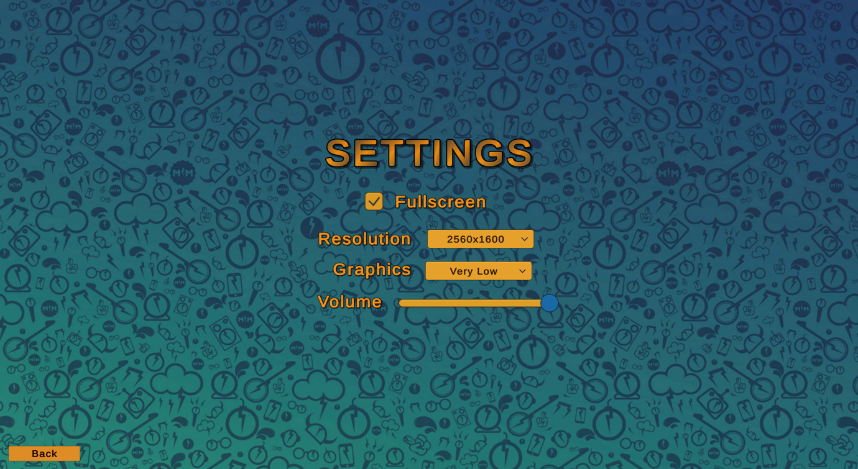

1. **Singleplayer Initial Screen**

* Below depicts the initial scene that the player is loaded into



CASE Tools

Changing User Requirements